BEENEUM MUIGAI
ANALYSTLAB AFRICA — WEEK 4 ASSIGNMENT
Consumer Complaint Monitoring and Response Dashboard
Consumer Complaint Trends and Response Intelligence Platform
Track: Data Analytics
Dataset: Bank of America Consumer Complaints (2017–2023)
Tools: Microsoft Power BI, Power Query and DAX
Project Overview
This project analyses consumer complaints recorded against Bank of America between 2017 and 2023. It focuses on complaint volumes, financial products, reported issues, geographical distribution, company response classifications and complaint-forwarding intervals.
The objective was to transform the supplied complaint records into an interactive reporting solution that helps stakeholders monitor complaint patterns and understand recorded company response performance.
Business Problem
Financial institutions receive complaints relating to different financial products and services. Without an organised monitoring system, stakeholders may find it difficult to identify recurring issues, monitor complaint volumes, understand response patterns and recognise potential delays in complaint processing.
The project addresses the need for a reliable and interactive way to examine consumer complaints recorded against Bank of America.
DATA INSPECTION AND CLEANING
Data Preparation Approach
The dataset was imported into Power BI and inspected using Power Query before analysis.
The following activities were performed:
- Inspected the dataset structure, available fields and data types.
- Checked the uniqueness of Complaint ID.
- Investigated duplicate complaint IDs and duplicate records.
- Examined missing values in the available columns.
- Validated the submission and forwarding dates.
- Reviewed categorical values for inconsistencies.
- Created an additional field to calculate complaint-forwarding intervals.
- Checked the resulting values and data types.
- Preserved missing values where they represented meaningful business statuses.
- Created a Calendar table to support time-based analysis.

Cleaning Decisions
The seven missing Sub-product values were associated with the Checking or savings account product category and were retained.
The missing Sub-issue and Company public response values were also retained because the available records did not provide sufficient evidence to determine their correct replacements.

Date Validation
A custom validation column was created to compare Date submitted and Date received.
The validation logic was:
- If Date received was earlier than Date submitted, classify the record as Invalid.
- Otherwise, classify it as Valid.
The validation identified no invalid date sequences.
Additional Analytical Fields
A Forwarding Days field was created using the difference between Date received and Date submitted.
The resulting forwarding interval was converted to a whole-number field for numerical analysis.
The observed range was:
- Minimum: 0 days.
- Maximum: 275 days.
A forwarding interval group was also created to support the dashboard distribution chart:
- 0 Days
- 1–2 Days
- 3–7 Days
- 8–30 Days
- 31–100 Days
- Greater than 100 Days
A Calendar table was created with Year, Month Number, Month, Year-Month and Year-Month Sort fields. It was related to the complaint table using Date submitted to support chronological reporting.

KPI DEVELOPMENT AND DEFINITIONS
The analysis used DAX measures to calculate complaint volumes, response outcomes and forwarding performance.
Core Complaint Metrics
1. Total Complaints
Counts the distinct Complaint ID values in the selected reporting context.
2. Annual Complaint Volume
Counts complaints grouped by calendar year using Date submitted.
3. Monthly Complaint Volume
Counts complaints grouped by calendar month and year.
4. Complaints by Financial Product
Counts distinct complaints associated with each Product category.
5. Complaints by Reported Issue
Counts distinct complaints associated with each Issue category.
6. Complaints by Sub-product and Sub-issue
Counts complaints grouped by the more detailed product and issue classifications.
7. Product Contribution to Total Complaints
Calculated as:
Product Complaints ÷ Total Complaints × 100.
Company Response Metrics
8. Company Response Category Distribution
Counts complaints under each Company response to consumer category.
9. Timely Response Percentage
Calculated as:
Timely Responses ÷ (Timely Responses + Untimely Responses) × 100.
Only records with a valid Yes or No timeliness classification are included in the denominator. Blank records are excluded and reported separately.
10. In-Progress Complaints
Counts complaints whose Company response to consumer status is In progress.
Forwarding Metrics
11. Average and Median Complaint-Forwarding Interval
The average measures the arithmetic mean of Forwarding Days. The median identifies the middle forwarding interval when values are ordered.
12. Year-over-Year Complaint Volume Change
Calculated as:
(Current Year Complaints − Previous Year Complaints) ÷ Previous Year Complaints × 100.
These definitions provide a consistent basis for interpreting the dashboard and validating the calculations.

DASHBOARD DESIGN AND STRUCTURE
The final Power BI solution was organised into two interactive dashboards to consolidate the required monitoring areas into a manageable reporting experience.
Dashboard 1: Consumer Complaint Overview & Trends
Purpose: Provide an overview of complaint volumes, trends, products, issues and geographical distribution.
KPI Cards
- Total Complaints
- Most Complained-About Product
- Most Reported Issue
- States Covered
Visualisations
- Annual Complaint Trend — line chart.
- Complaints by Product — horizontal bar chart.
- Top 10 Complaint Issues — horizontal bar chart.
- Complaints by State — United States Shape Map.
Slicers
- Year
- State
- Product
- Submitted Via

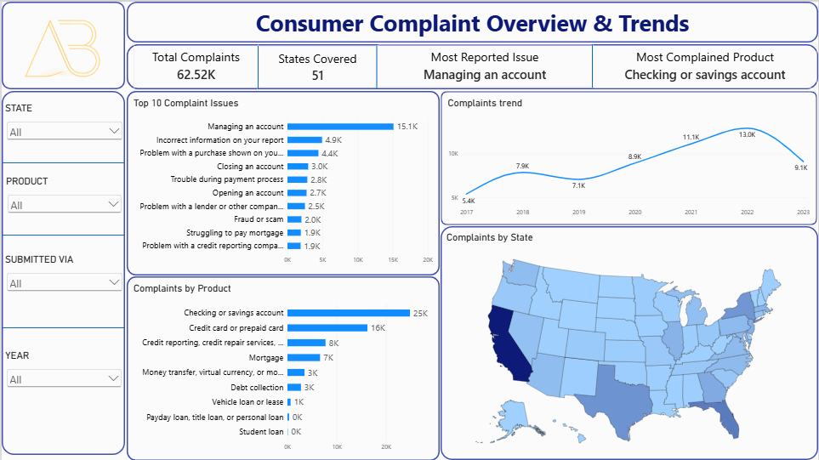
Dashboard 2: Company Response & Forwarding Performance
Purpose: Examine company response outcomes, response timeliness and complaint-forwarding intervals.
KPI Cards
- Timely Response Rate
- Untimely Responses
- In-Progress Complaints
- Monetary Relief Complaints
- Average Forwarding Days
- Same-Day Forwarding Rate
Visualisations
- Company Response Distribution — donut chart.
- Timely vs Untimely Responses — clustered column chart.
- Monthly Complaint Response Trends — line chart.
- Forwarding Days Distribution — column chart.
Slicers
- Year
- Product
- State
- Timely Response
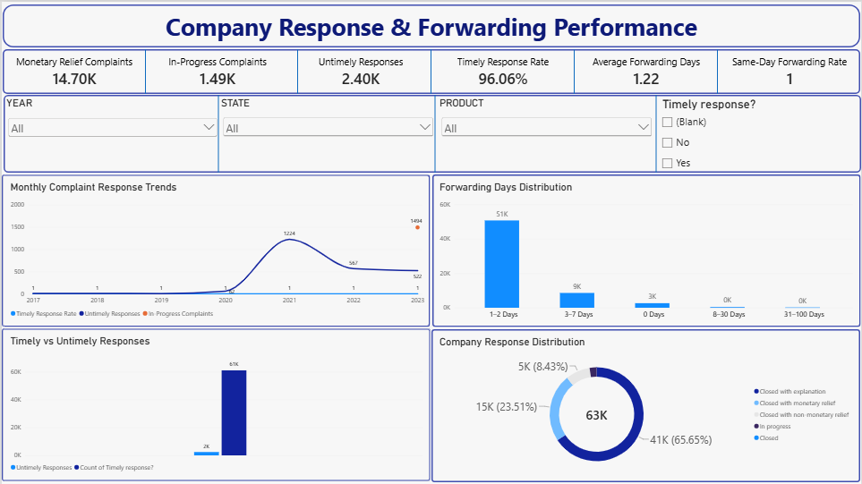

KEY FINDINGS — COMPLAINT VOLUMES AND PRODUCTS
Complaint Records Cover a Broad Reporting Period
The dataset contains 62,516 complaints recorded between May 2017 and August 2023. This provides a substantial historical basis for monitoring complaint activity.
The annual trend chart allows stakeholders to compare complaint volumes across reporting years. However, 2023 represents a partial reporting year because the supplied records end on 28 August 2023.
Checking and Savings Accounts Recorded the Highest Complaint Volume
Checking or savings account complaints totalled 24,814 records, making this the most complained-about financial product in the dataset.
This represents approximately 39.7% of all recorded complaints.

Managing an Account Was the Most Frequently Reported Issue
Managing an account recorded 15,109 complaints, making it the most frequently reported issue.
This highlights the importance of monitoring account-management experiences and the operational processes associated with them.

KEY FINDINGS — COMPANY RESPONSES
Most Complaints Were Recorded as Closed with Explanation
The recorded company response distribution was:
- Closed with explanation: 41,044.
- Closed with monetary relief: 14,697.
- Closed with non-monetary relief: 5,273.
- In progress: 1,494.
- Closed: 8.
Closed with explanation was the most frequently recorded response category.
These categories describe the recorded response classifications. They do not independently establish whether consumers were satisfied with the outcome.
Most Classified Responses Were Marked as Timely
The dataset recorded:
- Timely responses: 58,619.
- Untimely responses: 2,403.
- In-progress complaints without a timeliness classification: 1,494.
The timely response rate was approximately 96.06%, calculated using only the 61,022 complaints with a valid Yes or No timeliness value.
The 1,494 in-progress records were excluded from the calculation.
In-Progress Complaints Remain an Important Monitoring Category
A total of 1,494 complaints were recorded as In progress.
These records should be monitored separately because they do not have a completed response classification or a valid timeliness indicator in the supplied dataset.

KEY FINDINGS — COMPLAINT FORWARDING
Most Complaints Were Forwarded on the Same Day
A total of 49,634 complaints had a forwarding interval of zero days.
This represents approximately 79.39% of all recorded complaints.
The Average Forwarding Interval Was Relatively Short
The average complaint-forwarding interval was approximately 1.22 days, while the median was zero days.
The difference between the average and median indicates that some longer forwarding intervals increased the average.
A Small Number of Records Had Unusually Long Forwarding Intervals
The maximum observed forwarding interval was 275 days.
Fewer than 20 records had forwarding intervals exceeding 100 days. These records were inspected, but no clear relationship with a particular product or issue was apparent from the initial review.
Such records deserve further investigation because they may represent exceptional processing circumstances or data-quality concerns.

BUSINESS RECOMMENDATIONS
Based on the findings, the following actions are recommended:
1. Prioritise Monitoring of Checking and Savings Account Complaints
Since checking and savings accounts represent the largest product complaint category, management should regularly review recurring issues within this product group.
Further investigation should identify the sub-products and specific issues contributing to the volume.
2. Strengthen Monitoring of Account-Management Issues
Managing an account was the most frequently reported issue.
The organisation should review complaint patterns associated with account management and investigate whether recurring operational processes or customer-service experiences require attention.
3. Monitor Untimely and In-Progress Complaints
Although the recorded timely response rate was high, 2,403 complaints were classified as untimely and 1,494 remained in progress.
A monitoring process should flag these records for review and track changes in their status over time.

SLIDE 15: CONCLUSION
The analysis demonstrates how consumer complaint records can be transformed into meaningful information for monitoring financial services operations.
The findings show that checking and savings accounts accounted for the largest complaint volume, Managing an account was the most frequently reported issue, most classified responses were marked timely, and a substantial proportion of complaints were forwarded to companies on the same day.
The dashboards provide stakeholders with an interactive way to monitor these patterns and investigate complaint activity across different products, states and reporting periods.
Further analysis of detailed product and issue combinations, exceptional forwarding intervals and future complaint volumes would strengthen the solution.
Final Takeaway
A well-structured complaint monitoring dashboard helps turn raw complaint records into accessible, validated information that supports better investigation, monitoring and operational decision-making.

ATTRIBUTES
Primary Data Source
Consumer Financial Protection Bureau (CFPB).
Dataset
Consumer Complaints on Financial Products and Services — Bank of America, 2017–2023.
Supplied Files
- Consumer_Complaints.xlsx
- ConsumerComplaints_DataDictionary.csv
Analytical Tools
- Microsoft Power BI
- Power Query
- Data Analysis Expressions (DAX)
Programme
AnalystLab Africa — Experience Lab Internship Programme
Week 4 — Data Analytics Track
#AnalystLabAfrica

